Tabish Parkar

Formative Assessment 1:

Workflow Management

05HA2309970

Bellville

* 1. Process Identification is the initial part in Business Process Management, it includes finding and defining the variety of business processes or methods that exist in a business or organization. This would involve the following steps for ABC Manufacturing:

Determining Business Goals - Defining the overall strategic objectives of ABC Manufacturing, such as increasing efficiency, enhancing customer satisfaction along with minimizing order processing times.

Identifying Key Processes - Recognizing the main process(s) that impacts order processing and customer satisfaction. In ABC Manufacturing's case, these might involve:

Invoice or order receipt

Management of inventory

Processing of payments

Fulfilment of orders

Delivery and shipping

Aftersales and customer support or feedback

Defining Process Boundaries - Outlining where each process starts and concludes. For example, the Order Invoice process begins once a customer places an order and concludes when the order is confirmed.

Stakeholder Identification - Identifying the stakeholders involved in each process, including the employees from sales, warehouse, finance along with customer service departments.

Assessing Interdependencies - Understanding how these processes connect or interact with each other, mainly looking at dependencies and the flow of data, which may help in finding possible bottlenecks.

Prioritizing Processes for Improvement - Based on business goals and customer impact, ranking the identified processes. For ABC Manufacturing, the order processing system would probably be prioritized due to its direct impact on customer satisfaction.

* 1. Process Discovery is the process in business process management which involves collecting information about how already existing processes function, usually through multiple methods. The process discovery phase for ABC manufacturing would include the following elements:

Data Gathering or Collection – Collecting already existing documentation that is connected to the order processing system.

Involvement of Participants – Engaging the employees who have worked with the order processing system to provide more information about the current practices. This includes people from various departments:

* **Sales Team** - Customer requests and information on order entry.
* **Warehouse Staff** - All fulfilment processes along with Inputs on inventory management
* **Finance Department -** Information on payment processing and issues with billing.
* **Customer Support** - Aftersales on customer complaints and issues with the delay of orders.
* **Mapping Current Processes** – Using the gathered data, the current state of the order processing system is mapped out. This can be done with Business Process Model and Notation or flowchart diagrams which represent each step, stakeholder involvement, inputs and outputs.

Pain Point identification - Evaluating the current processes to find inefficiencies, hinderances and pain points for example:

* Delays in order confirmation.
* Inaccurate inventory counting could lead to fulfilment issues.
* Payment failures have higher rates or errors with processing.

Validation: Findings need to be discussed with stakeholders to certify their accuracy and gather additional statistics that may have been overlooked during previous assessments.

2.1.

Kaplan & Norton’s Strategy Map allows for a visual representation of an organization’s strategy, which links goals within the different points of view of the balanced scorecard, for ABC Manufacturing, correcting the order processing system with business strategy overall to improve customer satisfaction could be approached as follows:

**Financial Perspective -** Setting goals targeted at minimizing expenditure and increasing revenue through optimized order processing. Targets could include reducing total order processing times and reducing errors to minimize operational expenditure.

**Customer Perspective:** Defining the objectives that focus on bettering customer satisfaction by verifying timely order delivery, precise order fulfilment and a customer service that is highly respond able. This could mean measuring customer satisfaction through feedback surveys after an order has been fulfilled.

**Internal Processes Perspective:** Identifying important internal processes that need optimization to achieve both financial and customer goals. For ABC Manufacturing, main areas could include streamlining order receipts, improving inventory checking processes and ensuring faster payment processing.

**Learning & Growth Perspective:** Focusing on organizational culture and employee training. For ABC Manufacturing, providing a great training program to staff on the new BPM tools and optimizing communication across departments regarding order processing would be important.

**Linking Objectives:** The strategy map will visually connect goals across all four points of view. For example, the objective of a quicker payment process in the internal processes perspective directly supports the financial objective of reducing operational costs while also improving customer satisfaction by reducing order delays connected to payment issues.

2.2. **Financial Perspective:**

Objective - Reducing order processing expenditure.

Objective – Increasing revenue with higher order volumes.

**Customer Perspective:**

Objective – Improving aftersales and customer satisfaction ratings.

Objective - Decreasing order delivery times.

**Internal Processes Perspective:**

Objective - Streamlining order processing.

Objective - Reducing incidents of order fulfilment errors.

**Learning & Growth Perspective:**

Objective - Enhancing employee training and knowledge on BPM methods.

Objective – Fostering a collaboration between departments.

3.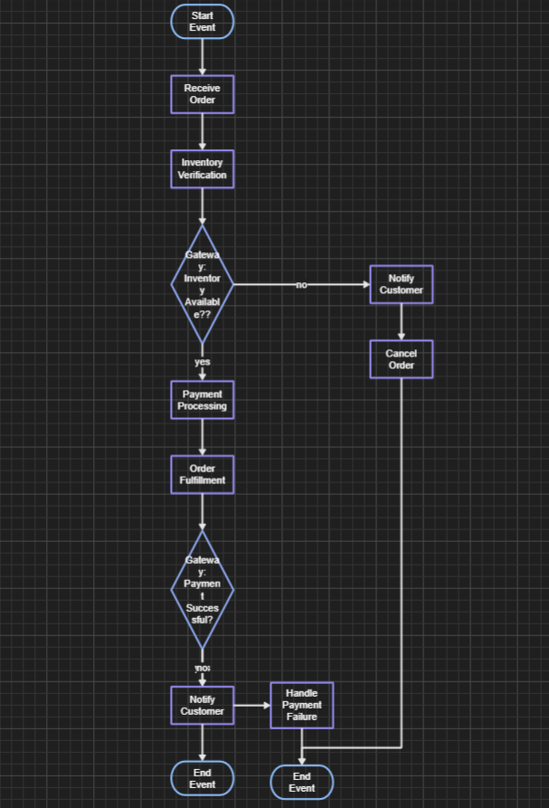

4.